Winter
# Source: AI Source: Provided by: [Data Path: Persons Table -> ID Column: 1, Name_En Column: Motasem Essam] -> From: [ChatGPT] on [7/17/2026]
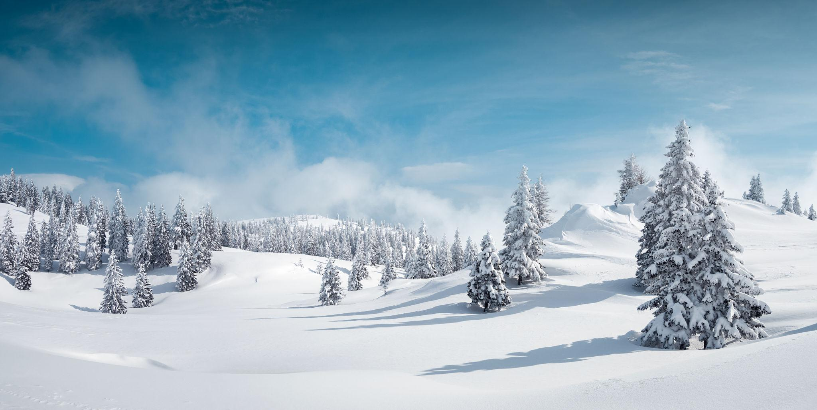
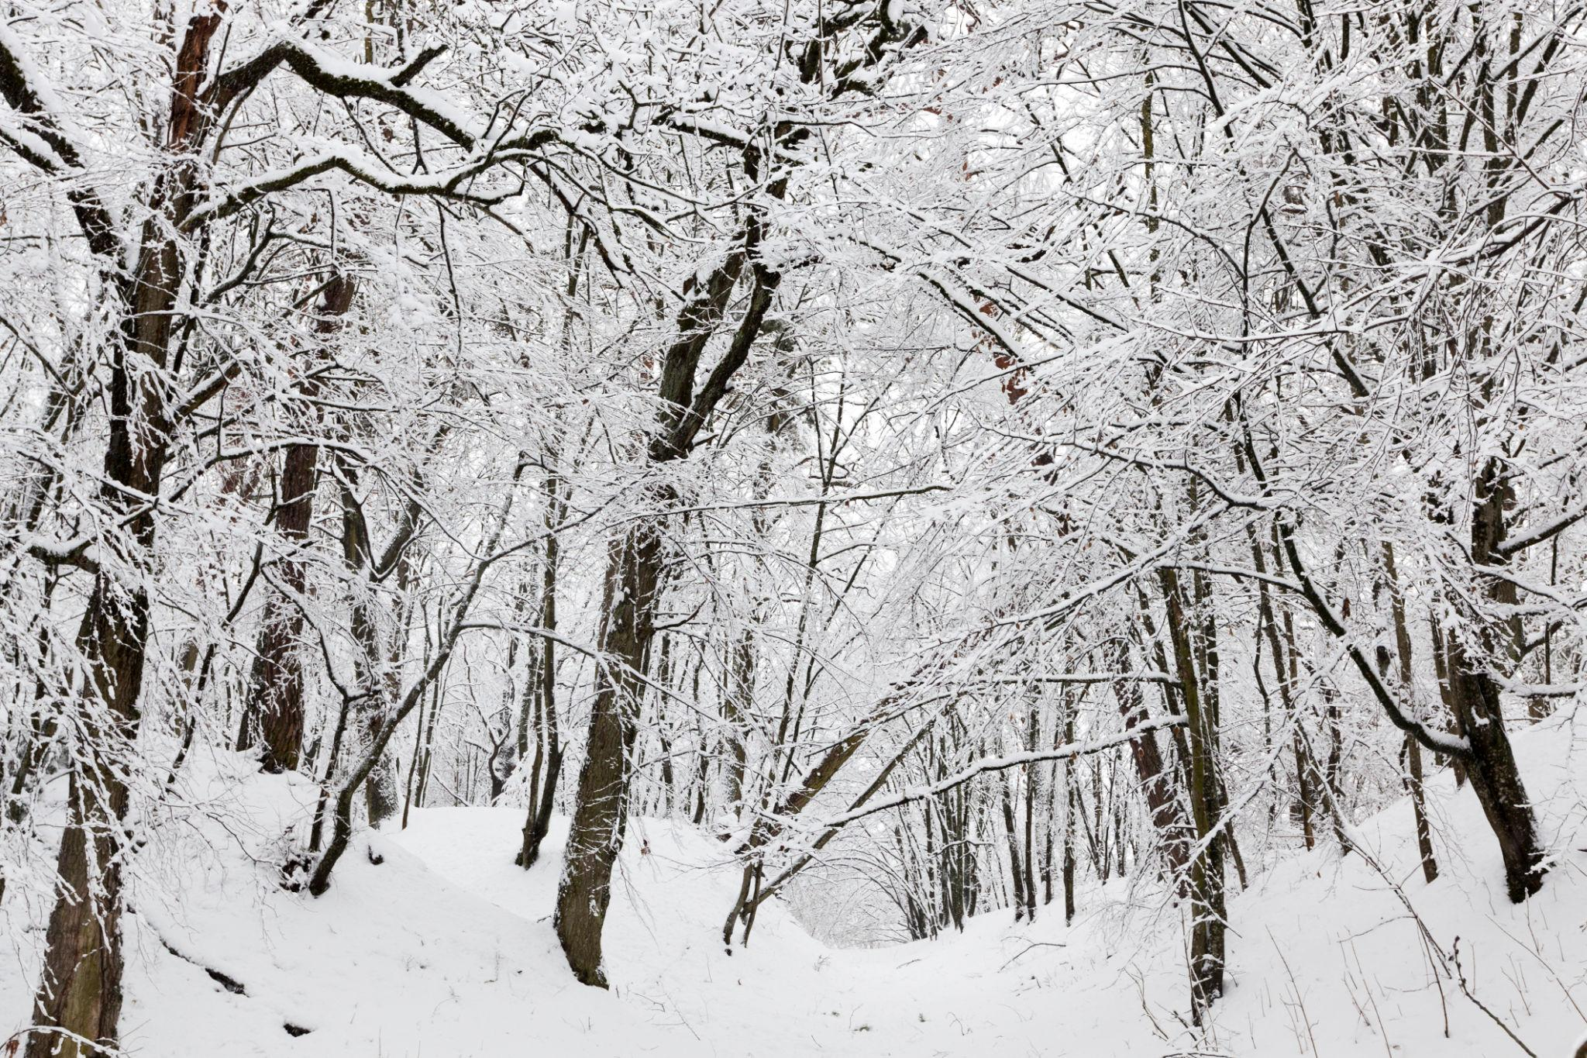
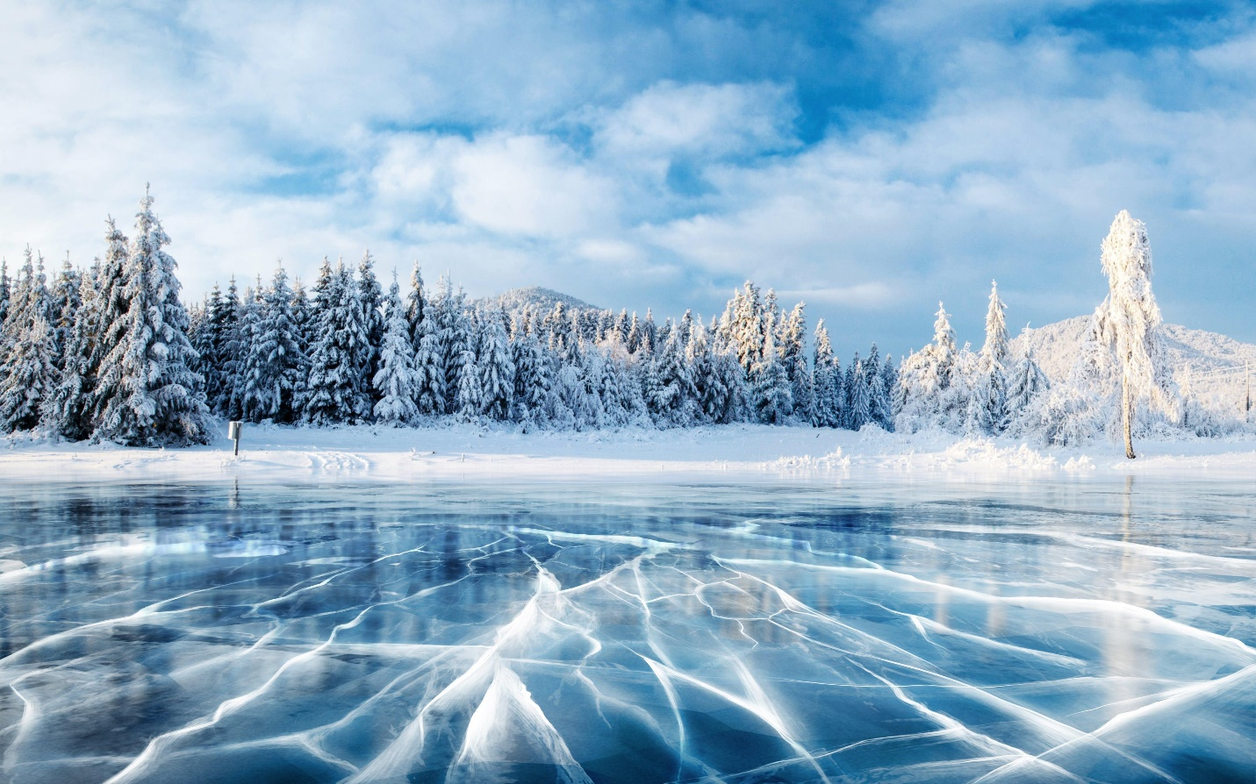
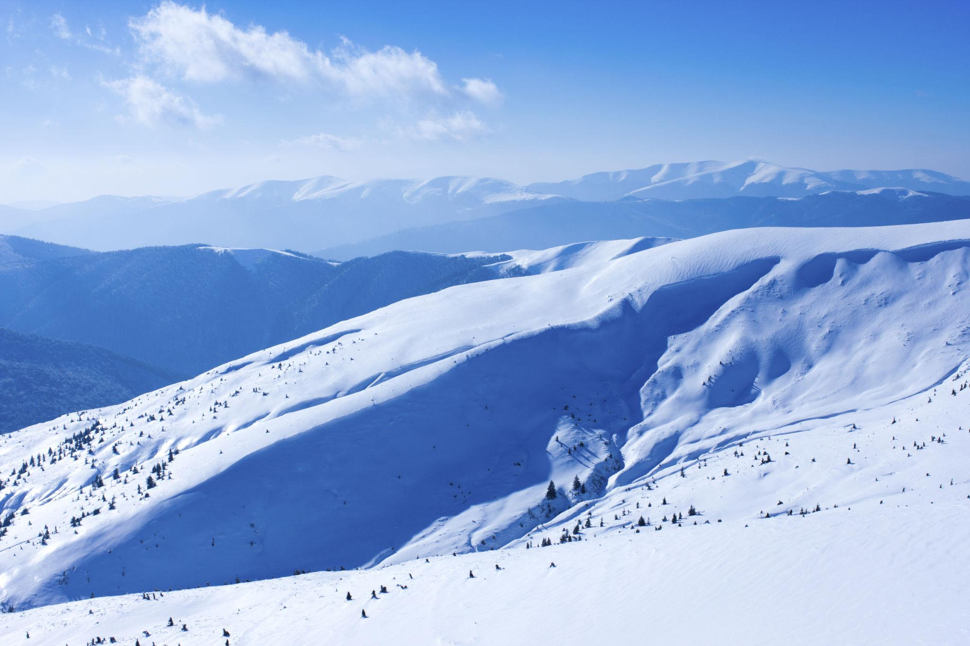
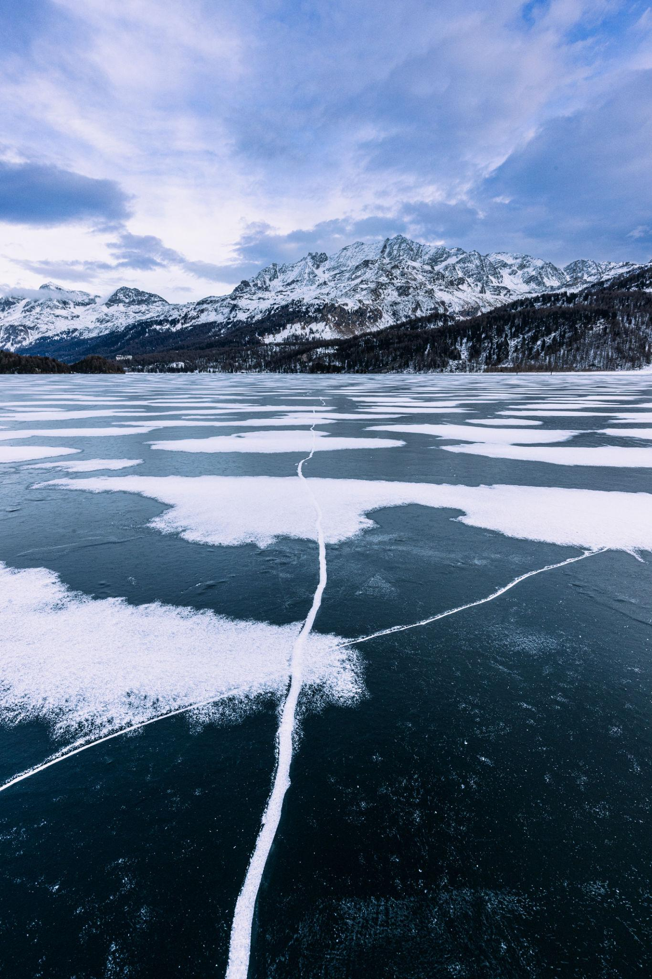
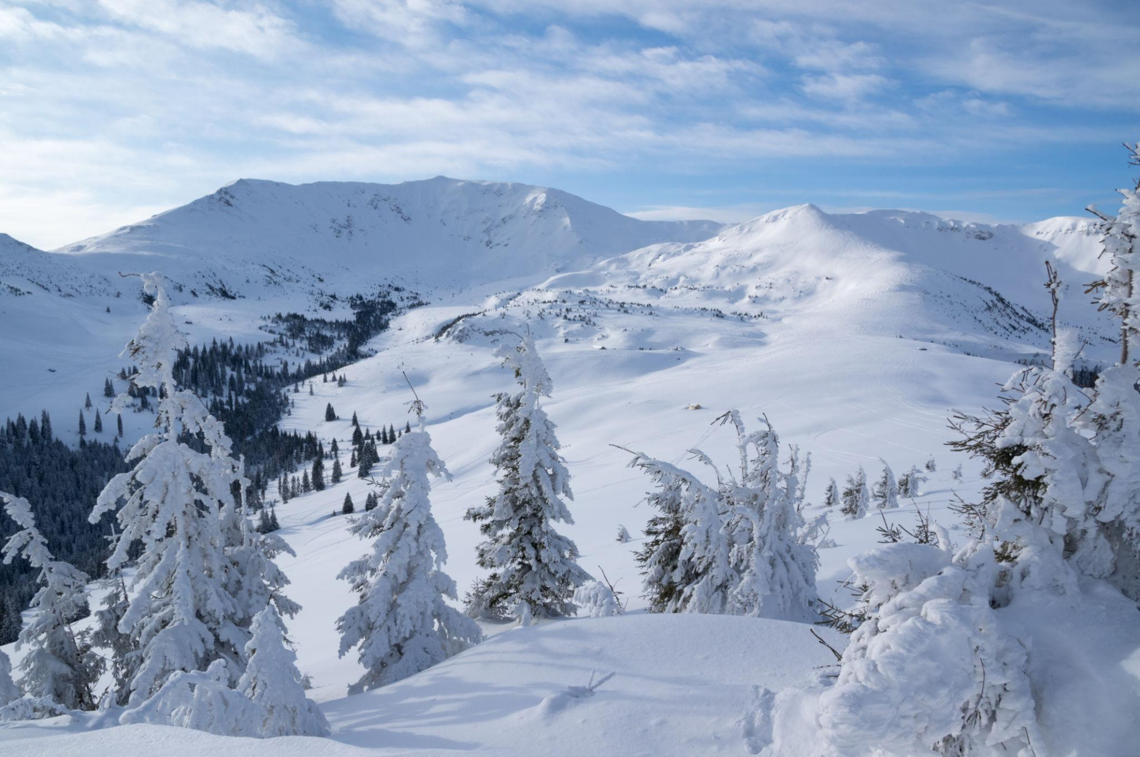
Winter is the coldest season of the year, occurring between autumn (fall) and spring. It is characterized by low temperatures, the shortest daylight hours, frost, snow in many regions, and reduced plant growth. During winter, many animals either migrate, hibernate, or reduce their activity to survive the colder conditions.
Winter occurs because a hemisphere is tilted away from the Sun, receiving the least direct sunlight and the shortest days of the year.
The relationship between Earth's tilt and the reduced sunlight that produces winter is illustrated below.

Definition
# Source: AI Source: Provided by: [Data Path: Persons Table -> ID Column: 1, Name_En Column: Motasem Essam] -> From: [ChatGPT] on [7/17/2026]
Winter is the season between autumn and spring, characterized by the lowest temperatures of the year, the shortest daylight hours, and reduced biological activity in many ecosystems.

Position in the Year
# Source: AI Source: Provided by: [Data Path: Persons Table -> ID Column: 1, Name_En Column: Motasem Essam] -> From: [ChatGPT] on [7/17/2026]
Winter occurs:
- After Autumn (Fall)
- Before Spring

Typical Months
# Source: AI Source: Provided by: [Data Path: Persons Table -> ID Column: 1, Name_En Column: Motasem Essam] -> From: [ChatGPT] on [7/17/2026]
Northern Hemisphere
- December
- January
- February
Southern Hemisphere
- June
- July
- August

Beginning of Winter
# Source: AI Source: Provided by: [Data Path: Persons Table -> ID Column: 1, Name_En Column: Motasem Essam] -> From: [ChatGPT] on [7/17/2026]
Astronomical Winter
Winter begins at the:
- Winter Solstice
Around:
- December 21–22 (Northern Hemisphere)
- June 20–21 (Southern Hemisphere)
The winter solstice is the day with the shortest daylight and longest night of the year in that hemisphere.

Weather Characteristics
# Source: AI Source: Provided by: [Data Path: Persons Table -> ID Column: 1, Name_En Column: Motasem Essam] -> From: [ChatGPT] on [7/17/2026]
Winter weather is generally:
- Cold
- Frosty
- Snowy in many regions
- Windy
- Dry in some climates and wet in others
Typical conditions include:
- Low temperatures
- Frost
- Ice
- Snowfall (in colder regions)
- Dense fog in some areas

Temperature
# Source: AI Source: Provided by: [Data Path: Persons Table -> ID Column: 1, Name_En Column: Motasem Essam] -> From: [ChatGPT] on [7/17/2026]
During winter:
- Temperatures reach their lowest annual averages.
- The Sun is lower in the sky.
- Less solar energy reaches the Earth's surface.

Daylight
# Source: AI Source: Provided by: [Data Path: Persons Table -> ID Column: 1, Name_En Column: Motasem Essam] -> From: [ChatGPT] on [7/17/2026]
During winter:
- Days are the shortest of the year.
- Nights are the longest.
- The Sun rises later and sets earlier.

Changes in Nature
# Source: AI Source: Provided by: [Data Path: Persons Table -> ID Column: 1, Name_En Column: Motasem Essam] -> From: [ChatGPT] on [7/17/2026]
Winter is a period of dormancy and survival.
Plants
- Many deciduous trees have no leaves.
- Plant growth slows or stops.
- Some plants become dormant.
- Evergreen trees remain green throughout the season.
Animals
- Some birds migrate to warmer regions.
- Some mammals hibernate.
- Other animals grow thicker fur or feathers.
- Many species reduce their activity to conserve energy.

Agriculture
# Source: AI Source: Provided by: [Data Path: Persons Table -> ID Column: 1, Name_En Column: Motasem Essam] -> From: [ChatGPT] on [7/17/2026]
Winter farming activities may include:
- Protecting crops from frost.
- Maintaining equipment.
- Growing winter crops in suitable climates.
- Preparing for spring planting.

Human Activities
# Source: AI Source: Provided by: [Data Path: Persons Table -> ID Column: 1, Name_En Column: Motasem Essam] -> From: [ChatGPT] on [7/17/2026]
People often:
- Wear warm clothing.
- Use heating systems.
- Enjoy winter sports such as skiing and ice skating.
- Build snowmen in snowy regions.
- Celebrate seasonal holidays.

Major Winter Celebrations
# Source: AI Source: Provided by: [Data Path: Persons Table -> ID Column: 1, Name_En Column: Motasem Essam] -> From: [ChatGPT] on [7/17/2026]
Examples include:
- Christmas
- New Year
- Lunar New Year (in some years)
- Winter festivals in many cultures

Importance of Winter
# Source: AI Source: Provided by: [Data Path: Persons Table -> ID Column: 1, Name_En Column: Motasem Essam] -> From: [ChatGPT] on [7/17/2026]
Winter is important because it:
- Allows many plants to complete their natural life cycle.
- Controls populations of some pests and insects.
- Provides snow that stores water for spring and summer.
- Supports ecosystems adapted to cold climates.
- Marks a period of rest before spring growth begins.

Advantages
# Source: AI Source: Provided by: [Data Path: Persons Table -> ID Column: 1, Name_En Column: Motasem Essam] -> From: [ChatGPT] on [7/17/2026]
Winter provides:
- Snow for freshwater storage.
- Conditions for winter recreation.
- Natural dormancy for many plants.
- Seasonal ecological balance.

Challenges
# Source: AI Source: Provided by: [Data Path: Persons Table -> ID Column: 1, Name_En Column: Motasem Essam] -> From: [ChatGPT] on [7/17/2026]
Winter may also bring:
- Freezing temperatures
- Snowstorms
- Ice accumulation
- Hazardous travel conditions
- Increased heating demand
- Risk of hypothermia and frostbite

Comparison with Other Seasons
# Source: AI Source: Provided by: [Data Path: Persons Table -> ID Column: 1, Name_En Column: Motasem Essam] -> From: [ChatGPT] on [7/17/2026]
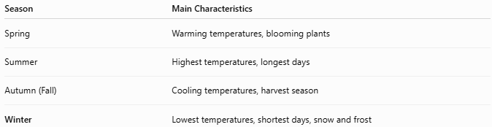
Season | Main Characteristics
Spring | Warming temperatures, blooming plants
Summer | Highest temperatures, longest days
Autumn (Fall) | Cooling temperatures, harvest season
Winter | Lowest temperatures, shortest days, snow and frost

Common Mistakes
# Source: AI Source: Provided by: [Data Path: Persons Table -> ID Column: 1, Name_En Column: Motasem Essam] -> From: [ChatGPT] on [7/17/2026]
- Assuming winter always brings snow (many regions experience cold winters with little or no snowfall).
- Believing winter occurs because the Earth is farther from the Sun (the primary cause is the Earth's axial tilt, not its distance from the Sun).
- Assuming both hemispheres experience winter at the same time (they experience opposite seasons).

Key Points
# Source: AI Source: Provided by: [Data Path: Persons Table -> ID Column: 1, Name_En Column: Motasem Essam] -> From: [ChatGPT] on [7/17/2026]
- Winter is the season between autumn and spring.
- It begins at the Winter Solstice.
- It has:
  - The lowest temperatures
  - The shortest daylight hours
  - The least direct sunlight
- Many plants become dormant.
- Animals migrate, hibernate, or adapt to the cold.
- Winter plays an important role in the Earth's seasonal and ecological cycles.

Conclusion
# Source: AI Source: Provided by: [Data Path: Persons Table -> ID Column: 1, Name_En Column: Motasem Essam] -> From: [ChatGPT] on [7/17/2026]
Winter is the coldest season of the year, marked by low temperatures, short days, and reduced sunlight. It occurs when a hemisphere is tilted away from the Sun, causing it to receive the least solar energy. During winter, ecosystems adapt through plant dormancy and animal migration or hibernation, while people adjust their activities to colder conditions. Despite its challenges, winter is essential for maintaining ecological balance and preparing the natural world for the renewal of spring.

